# Structured Query Language (SQL)

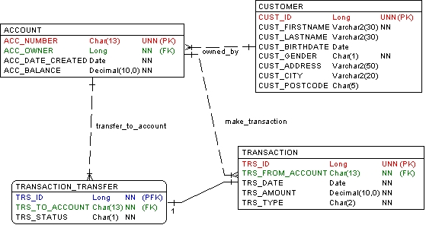

Note:

UNN : Unique, Not Null PK : Primary Key

FK : Foreign Key NN : Not Null

Table description:

1. CUSTOMER: contains all bank customer data

The column CUST_GENDER is set to 1 for male and 2 for female.

1. ACCOUNT: contains all customer accounts

The column ACC_OWNER is the Foreign Key which refers to the column CUST_ID of the table CUSTOMER.

1. TRANSACTION: records all transactions.

The column TRS_TYPE contains the transaction type with possible values:

* 1. DB: for debit transaction.
  2. CR: for credit transaction.
  3. TF: for money transfer. The column TRS_FROM_ACCOUNT contains the source account.

1. TRANSACTION_TRANSFER: contains additional information if the transaction is money transfer.

The column TRS_STATUS contains one of the following values:

* 1. 0: if transaction is not executed yet
  2. 1: if transaction is executed successfully
  3. -1: if transaction is failed (e.g. the balance of source account (TRS_FROM_ACCOUNT) is not available)

# Questions

Create SQL queries for the following requirements:

1. Recapitulation of number of accounts owned by every customer.

Answer:

SELECT

c.CUST_ID,

c.CUST_FIRSTNAME,

c.CUST_LASTNAME,

COUNT(a.ACC_NUMBER) AS NUM_OF_ACCOUNTS

FROM

CUSTOMER c

LEFT JOIN

ACCOUNT a ON c.CUST_ID = a.ACC_OWNER

GROUP BY

c.CUST_ID, c.CUST_FIRSTNAME, c.CUST_LASTNAME;

1. All transactions created by John Michael sorted by account number and transaction date

Answer:

SELECT

t.TRS_ID,

t.TRS_FROM_ACCOUNT,

t.TRS_DATE,

t.TRS_AMOUNT,

t.TRS_TYPE

FROM

TRANSACTION t

JOIN

CUSTOMER c ON t.TRS_FROM_ACCOUNT = a.ACC_NUMBER

WHERE

c.CUST_FIRSTNAME = 'John' AND c.CUST_LASTNAME = 'Michael'

ORDER BY

t.TRS_FROM_ACCOUNT, t.TRS_DATE;